Laser Diode Module Power Supply «LDC-5»

The Power Supply provides pulsed performance of the Laser Diode Modules
Technical parameters
LDM
  - Peak LDM current 400 A
  - Max bias current 40 A
  - Max LDM voltage 400 V
  - LDM average power ≤ 500 W
  - LDM working pulse length 40 ÷ 3000 µs
  - Repetition rate single shots ÷ CW
  - Instability of the current amplitude ≤ 1 %
  - Power supply of pilot laser 5 V & 200 mA
Peltier Elements 1 & 2
  - Range of the temperature control 15 ÷ 90 ºC
  - Discreteness of the temperature control ± 0,1 ºC
  - Max voltage 24 V
  - Max current 8 A
Additional Temperature Interlock 12 ÷ 90 ºC
Photo Detector
  - linear range of the LDM photocurrent measurements 0,01 ÷ 160 µA
  - Scale factor of light power/current conversion 0 ÷ 100 W/µA
Trigger Delay
  - Tuning range of trigger delay 0 ÷ 400 µs
General
  - Power supply 1 (for LDM current) 3 ÷ 400 VDC
  - Power supply 2 (for Peltier Element) 24 VDC & 16 A
  - Dimensions 120 × 150 × 40 mm³
  - Weight 500 g
  - Storage temperature – 30 ÷ + 80 ºC
  - Operating temperature + 5 ÷ + 60 ºC
  - Ambient humidity < 98%

The control of the Power Supply is provided by personal computer according to RS232 or USB standard with software VLC3 and VITRONC.

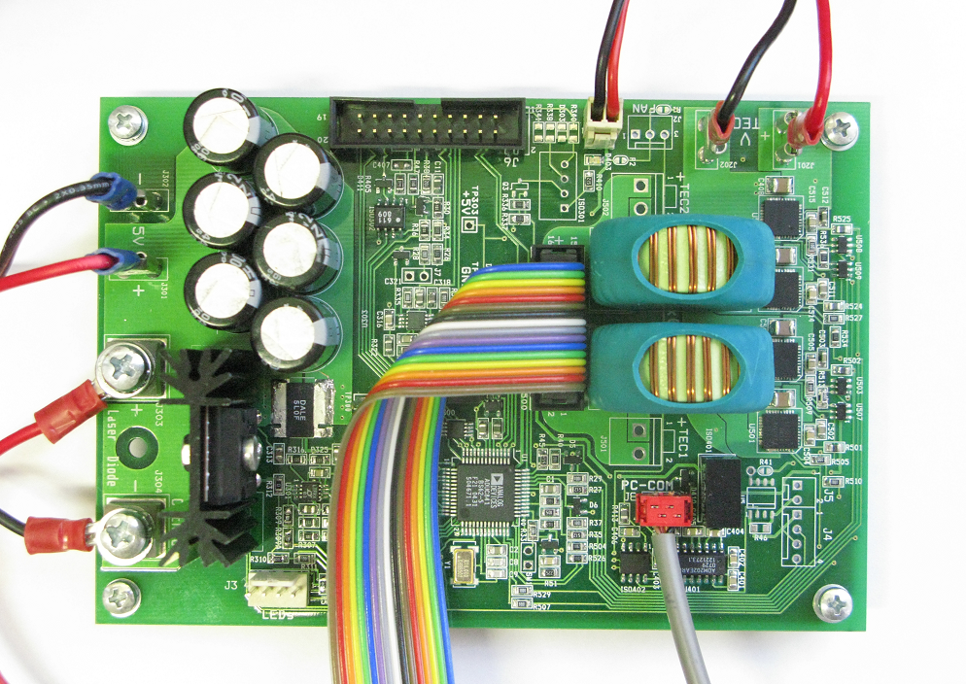

Main Board LDC-5

