**GRM RESONATOR DESIGN**



**PLEASE FILL IN THE FORM AS COMPLETELY AS POSSIBLE**

**RESONATOR**

|  |
| --- |
| 1. **Optimal Feedback, %** |
| 1. **Loss, OC area (other than output coupling), %** |
| 1. **Loss, HR area** |
| 1. **Refraction index, geometrical resonator length, positions of optical components, other than laser rod** |
| 1. **Current R1, R2 (cc-concave; cx-convex), if applicable** |
| 1. **Current Lc, L2; if applicable** |
| 1. **Desired Configuration (stable/unstable)** |
| 1. **Desired Resonator Length Lc (min/max)** |
| 1. **Desired L2** |
| 1. **Beam Profile to Be Optimized for Near Field/Far Field, etc.)** |

**GAIN MEDIUM (Laser Rod)**

|  |
| --- |
| 1. **Material** |
| 1. **Operational Wavelength** |
| 1. **Index of Refraction (if applicable)** |
| 1. **Loss Coefficient, cm-1 (if applicable)** |
| 1. **Single-Pass Unsaturated Gain G0=exp(g0Lg)=** |
| 1. **Thermal Lens (dioptre), if applicable** |
| 1. **Laser Rod Geometry: Cylindrical____; Rectangular_____; Slab______** |

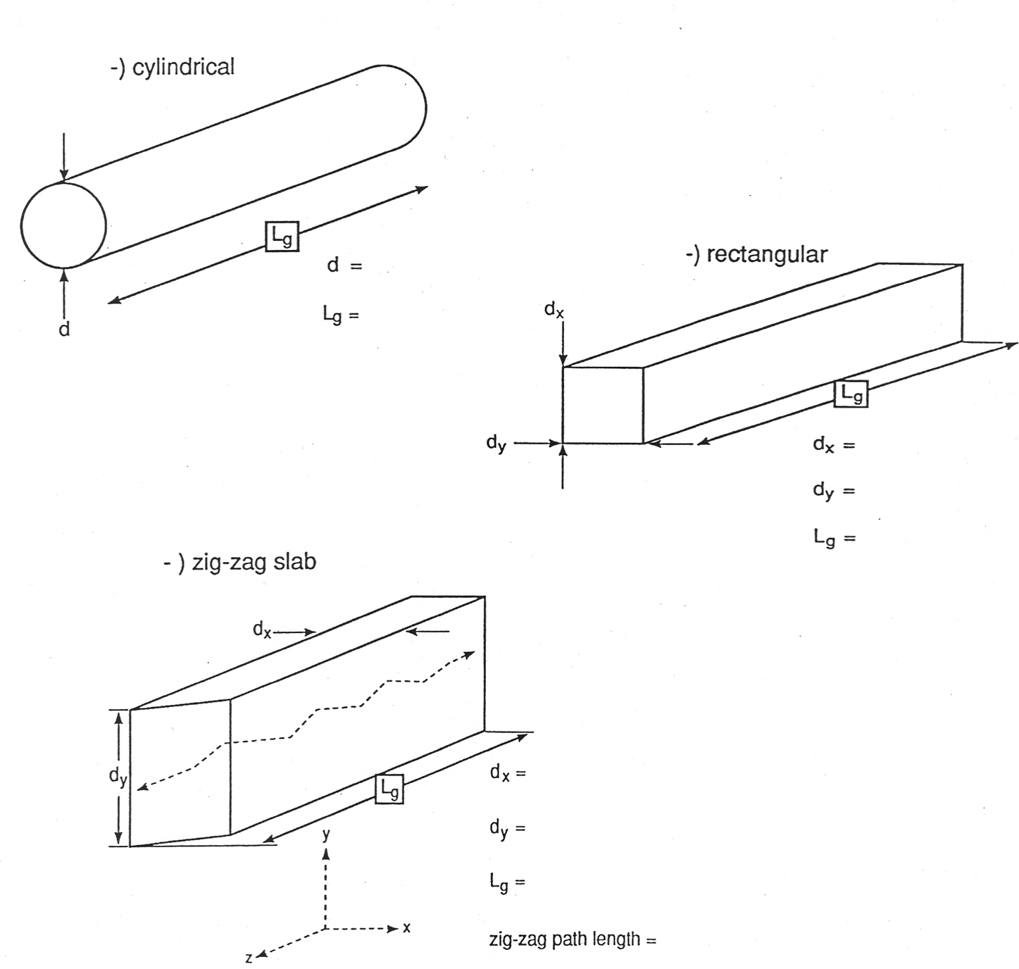

**OPERATING REGIME.**

|  |
| --- |
| 1. **Type: CW, Pulsed, Free-Running, Q-switched, etc.** |
| 1. **Pump Source: Flashlamp, diode, etc.** |
| 1. **Pump Power, Energy (W, J)** |
| 1. **Pulse Duration** |
| 1. **Desired Output Power, Energy (W, J)** |

**GRM SPECIFICATIONS:**

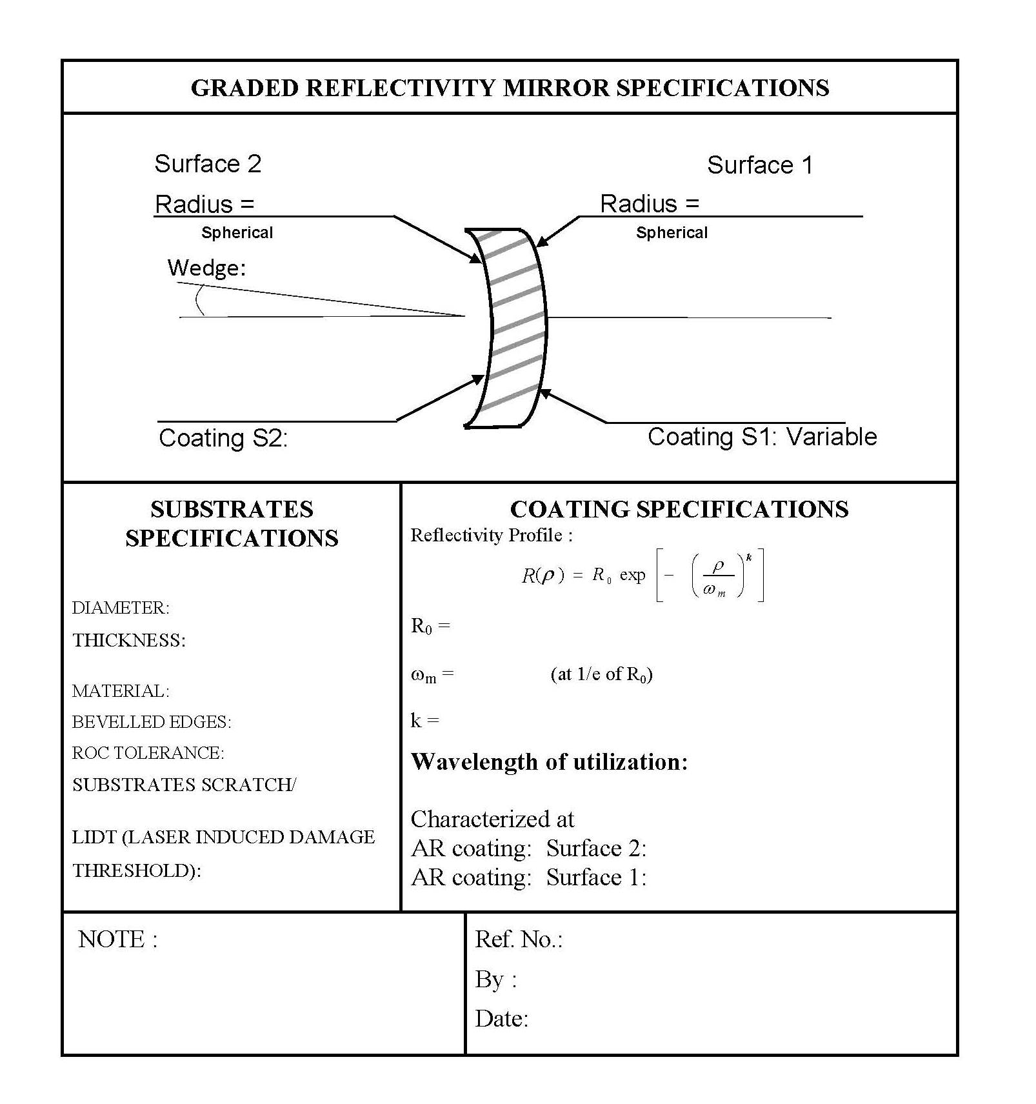

**CONTACT INFORMATION:**

|  |
| --- |
| **NAME: POSITION:** |
| **COMPANY:** |
| **ADDRESS:** |
| **CITY: STATE: POSTAL CODE: COUNTRY:** |
| **TEL.: FAX:** |
| **E-MAIL: WEBSITE:** |